Mohammad Rohaan 22I-2327 Sec-E

SOLUTION# 03:-
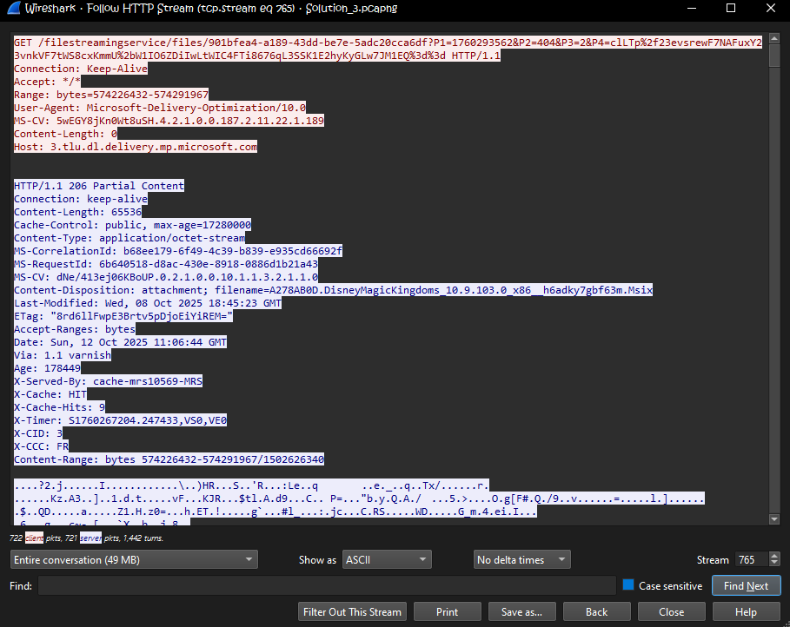
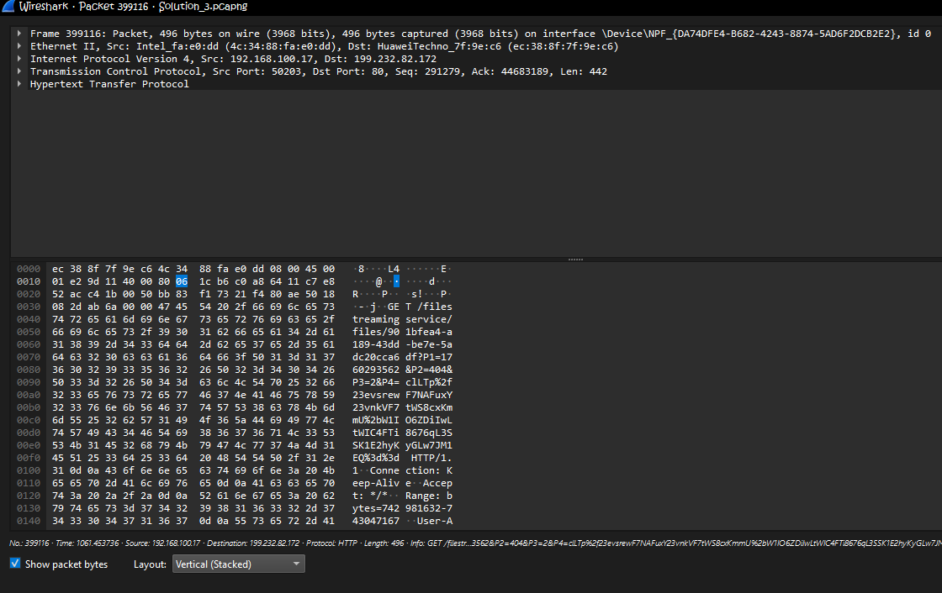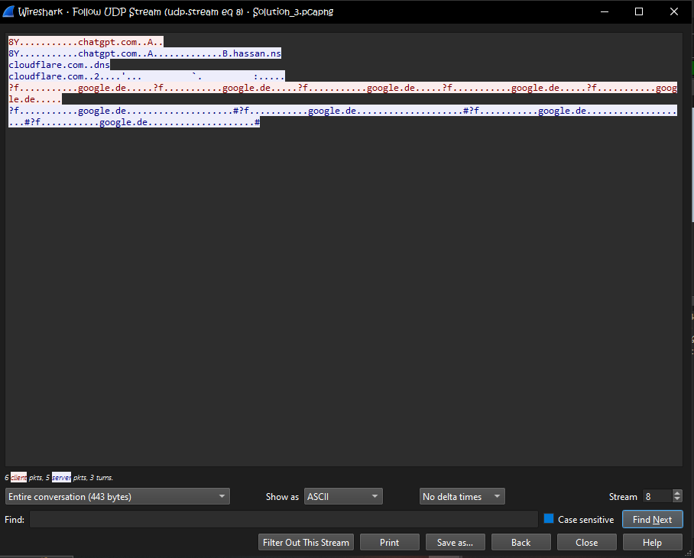
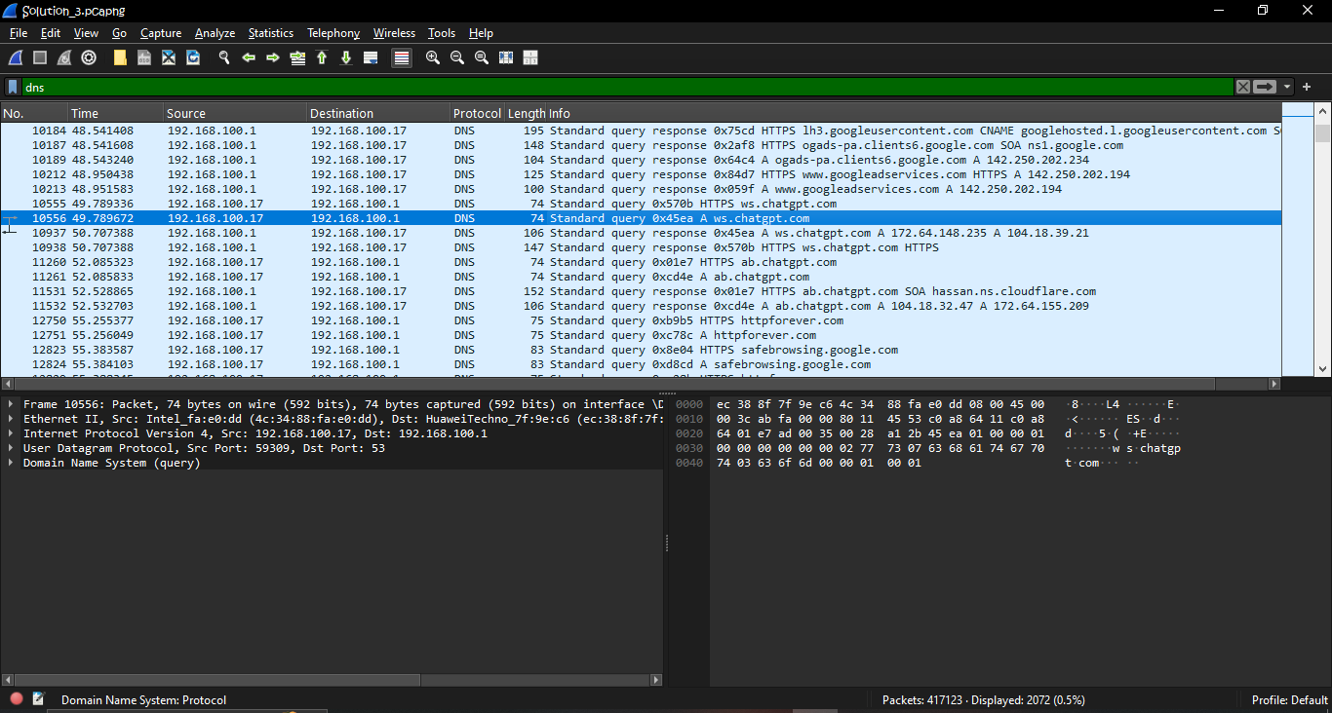
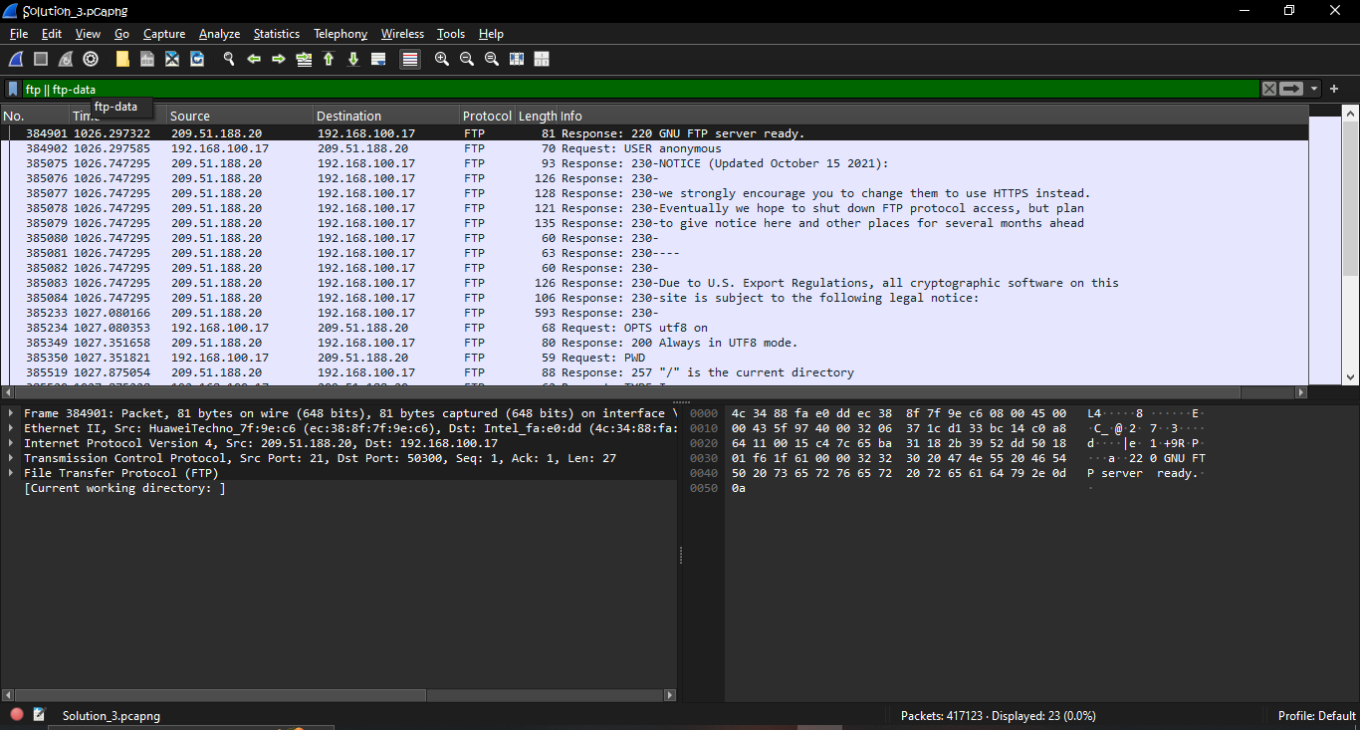
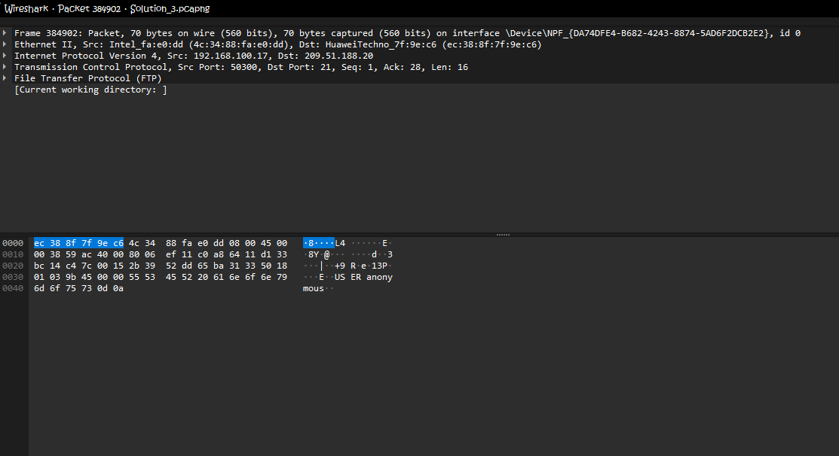
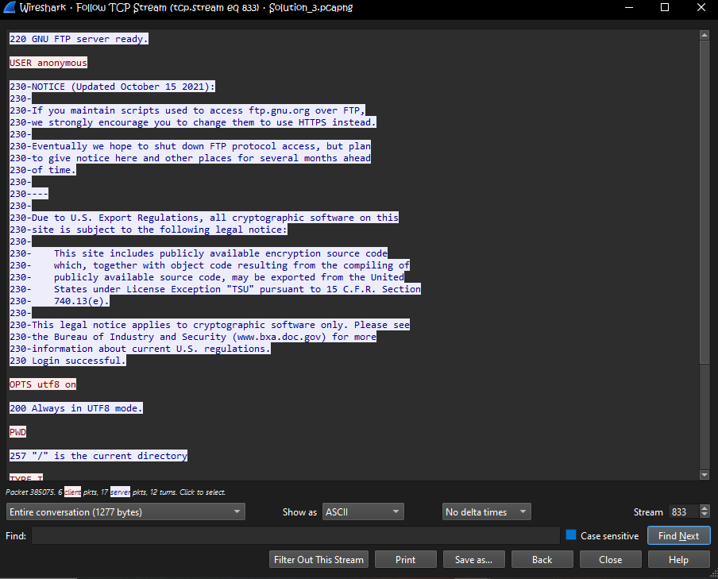
How HTTPS Protects Sensitive Data
HTTPS (Hypertext Transfer Protocol Secure) is a secure version of HTTP that protects the data exchanged between a user’s browser and a web server. It uses SSL/TLS encryption to ensure that all communication is private and cannot be read by attackers who might capture network traffic. This means that sensitive information such as passwords, personal details, and payment data are transmitted in encrypted form, making it extremely difficult for hackers to intercept or alter. In addition to encryption, HTTPS also verifies the identity of the website through digital certificates, preventing users from connecting to fake or malicious websites. This combination of encryption, authentication, and data integrity makes HTTPS a secure and reliable way to protect sensitive information on the internet.

Solution# 05:-
Given Data
- Buffer capacity = 50,000 packets
- Packet size = 1,000 bytes → Buffer size = 50,000×1,000=50,000 bytes (50 MB)
- Outgoing link = 100 Mbps = 100,000,000 bits/s
- Arrival rate during burst = 150 Mbps = 150,000,000 bits/s
- Burst duration = 10 s

1) Time until buffer overflows
Net excess arrival rate (bits/s) = arrival − outgoing
150,000,000−100,000,000=50,000,000 bits/s
Convert net excess to bytes/s:
50,000,000÷8=6,250,000 bytes/s
Time to fill buffer (seconds) = buffer bytes / net fill (bytes/s)
50,000,000÷6,250,000=8 seconds

2) How many packets will be dropped?
Burst lasts 10 s, overflow occurs at 8 s remaining burst time while buffer is full = 10−8=2 s
During those 2 seconds, the router still transmits at 100 Mbps but receives at 150 Mbps, so the excess traffic that cannot be buffered is dropped. Excess bits dropped in 2 s:
50,000,000 bits/s×2 s=100,000,000 bits
Convert to bytes:
100,000,000÷8=12,500,000 bytes
Number of packets dropped (1,000 bytes/packet):
12,500,000÷1,000=12,500 packets

3) Two advanced mechanisms networks use to avoid such losses (beyond increasing buffer size)

Networks use several advanced mechanisms to prevent packet loss beyond simply increasing buffer size. One effective method is Active Queue Management (AQM), such as RED or CoDel, which continuously monitors queue length or delay and proactively drops or marks packets before buffers overflow. This early signaling helps maintain low latency, prevents bufferbloat, and avoids sudden bursts of packet loss by encouraging senders to slow down gradually. Another important mechanism is Congestion Feedback and Traffic Policing, which includes Explicit Congestion Notification (ECN) and traffic shaping or rate limiting. ECN marks packets during congestion instead of discarding them, allowing TCP senders to adjust their rates smoothly, while traffic shaping regulates data flow to prevent sudden spikes that could overwhelm the network. Together, these methods improve overall stability, fairness, and performance by controlling congestion intelligently rather than reacting after packet loss has already occurred.

Solution# 04:-
Given
- Link rate R=350 Mb/s=350,000,000 bits/s
- Average object size L=250,000 bits
- Request arrival rate λ=35 requests/s
- Average Internet = 2.5

Service time per object
S=L/R=250,000/350,000,000=0.0007142857 =7.1429x${10}^{-4}s$
Service rate
μ=1/S≈1400 requests/s
Utilization
ρ=λ*S=35×0.0007142857=0.025

(i) Total average response time (no cache)
Access delay
T access= S/(1-ρ) = 0.0007142857 ​= 0.9750.0007142857 ​= 0.000732442 s ≈ 7.3244×${10}^{-4}s$

Total average response time
T total = T access + T Internet = 0.00073244 + 2.5 = 2.50073244 seconds

With a cache on the LAN (miss rate = 0.7)
Interpretation / model:
- T cache = 0.01 s
- Λ miss = 0.7×35=24.5 req/s

Ρ miss = λ miss * S = 24.5×0.0007142857=0.0175

Access delay for misses

T access,miss ​= S / (1 – ρ miss) ​= 0.0007142857/(1 − 0.0175) = 0.0007275 s.

Total response time for a miss

T miss = T access,miss + T Internet = 0.0007275+2.5=2.5007275 s
Total (average) response time per request
T avg = (0.7)T miss + (0.3)T cache = 0.7×2.5007275+0.3×0.01
T avg = 1.75050925+0.003 = 1.75350925 seconds

